TABLE OF CONTENTS
CHAPTER 1: INTRODUCTION
1.1 Background of the Study
1.2 Motivation
1.3 Problem Statement
1.4 Objectives of the Project
1.5 Scope and Limitations
1.6 Report Organization
CHAPTER 2: LITERATURE REVIEW
2.1 Evolution of Web Application Architectures
2.2 The MERN Stack
2.3 Real-Time Communication Technologies
2.4 Security Standards in Modern Web Apps
CHAPTER 3: SYSTEM ANALYSIS
3.1 Requirement Analysis
3.2 Feasibility Study
3.3 Use Case Analysis
CHAPTER 4: SYSTEM DESIGN
4.1 System Architecture
4.2 Database Design
4.3 API Design
4.4 User Interface Design
CHAPTER 5: IMPLEMENTATION
5.1 Development Environment
5.2 Backend Implementation
5.3 Frontend Implementation
5.4 Real-Time Messaging Implementation
CHAPTER 6: TESTING
6.1 Testing Methodologies
6.2 Test Cases and Results
CHAPTER 7: RESULTS AND DISCUSSION
7.1 Performance Analysis
7.2 User Experience Feedback
7.3 Comparison with Objectives
CHAPTER 8: CONCLUSION AND FUTURE SCOPE
8.1 Conclusion
8.2 Future Scope
REFERENCES

CHAPTER 1: INTRODUCTION
1.1 Background of the Study
Today’s education system has changed a lot with the rise of technology. Learning platforms like Canvas and Moodle have definitely made it easier to manage classes, but one important area is still lacking—professional networking inside universities. Moving from college to the industry is a major step, and it often depends on “tacit knowledge,” meaning the unwritten rules, real-world insights, soft skills, and career advice that you don’t usually get from textbooks. Most of this knowledge lives with alumni who have already gone through the same journey. CampusConnect aims to bridge this gap by creating a dedicated platform where students can communicate with alumni in real time. Unlike general social media, it focuses specifically on student mentorship and provides guidance that fits the academic and career needs of university learners.
1.2 Motivation
The idea behind developing CampusConnect comes from two main motivations:
- Educational Motivation: Many students don’t get proper mentorship simply because they don’t know the right people or are too shy to approach someone. Mentorship often happens by chance, and that leaves a lot of students behind. By creating a digital platform, we can make mentorship equally accessible to everyone, regardless of their personality or background.
- Technological Motivation: On the technical side, this project is also a chance to build a full, production-level application using the MERN stack (MongoDB, Express, React, and Node.js). A key goal is to understand how real-time, stateful features like WebSockets can be integrated into a system that normally works in a stateless, RESTful manner. This is a common challenge in modern software development, and the project serves as a practical way to explore it.
1.3 Problem Statement
Even though platforms like LinkedIn and messaging apps like WhatsApp exist, they still don’t provide a proper space for smooth interaction between students and alumni. This gap creates a few clear problems:
- Slow Communication: Most alumni-student conversations still happen through email, where replies often take one to two days. This delay breaks the flow of meaningful mentorship and makes discussions feel disconnected.
- Privacy Concerns: Both students and alumni hesitate to share their personal phone numbers for WhatsApp or SMS. This creates an awkward barrier and stops many potential conversations from even starting.
- Lack of Context: On LinkedIn, student messages easily get buried under recruiter outreach and promotional content. There isn’t a dedicated environment where the main purpose is genuine mentorship and academic guidance.
- Scattered Data: Universities usually store alumni information in old spreadsheets or outdated SQL systems. These formats aren’t built for real-time interaction, which makes it difficult to create any dynamic or engaging networking experience.
1.4 Objectives of the Project
The main goal of this project is to develop a web application that is stable, efficient, and secure enough to handle real usage. To achieve this, the technical objectives are:
- Reducing Latency: The system should deliver messages almost instantly, with a target of under 100ms using socket.io, so conversations feel smooth and real-time.
- Strengthening Security: The app will use JWT authentication along with HTTP-only cookies (or protected local storage) to prevent attacks like XSS. Passwords will be safely stored using bcrypt hashing.
- Handling Multiple Users: The server should be able to manage at least 100 users chatting at the same time without slowing down, taking advantage of Node.js’s non-blocking event loop.
- Improving User Experience: Features like instant UI updates and typing indicators will be added to make the platform feel as responsive as popular mobile chat apps.
- Maintaining Data Accuracy: A well-structured MongoDB schema will be designed to keep user data and message records consistent and reliable.

1.5 Scope and Limitations
Scope
- Authentication Module: Includes user registration, login, JWT-based authentication, and secure password hashing.
- Profile Module: Allows users to choose an avatar (via the Multiavatar API) and update details like their bio and skill set.
- Discovery Module: Provides a searchable list of students and alumni so users can easily find and connect with each other.
- Chat Module: Supports real-time, one-to-one text conversations with emojis and saved message history.

Limitations
- No Group Chat: The system currently handles only direct one-to-one communication through a server relay, so group conversations are not supported.
- No File Sharing: Uploading files such as images or PDFs isn’t available yet, as it would require integrating cloud storage like AWS S3.
- Single Tenant Design: The platform is built for use within a single university and is not optimized for a multi-institution SaaS model.
- Temporary Socket Mapping: Active socket connections are stored in memory (Map<userId, socketId>), which means all connections reset if the server restarts. Persistent storage like Redis would be needed to fix this.
1.6 Report Organization
This thesis is organized in a way that takes the reader step-by-step from the core problem to the final working solution.
- Chapter 2 explains the theoretical background and gives an overview of the technologies used in the project.
- Chapter 3 focuses on the engineering analysis and the process of gathering requirements.
- Chapter 4 outlines the system architecture, design decisions, and database schema.
- Chapter 5 walks through the actual implementation, including the main code structure and logic flow.
- Chapter 6 discusses how the system was tested and validated.
- Chapter 7 presents the performance results and evaluates how well the system meets its goals.
- Chapter 8 ends with the final conclusions and suggests possible improvements for future work.

CHAPTER 2: LITERATURE REVIEW
2.1 Evolution of Web Application Architectures
The evolution of the web can be understood through three major stages:
- Static Web (Web 1.0): Early websites were made up of simple HTML and CSS files with almost no interaction. Users could only read information, not interact with it.
- Dynamic Server-Side Web (Web 2.0): Technologies like PHP, Ruby on Rails, and JSP allowed servers to generate full HTML pages for every request. While this brought more interactivity, it also meant higher bandwidth usage and slower page transitions.
- Single Page Applications (SPA): Frameworks such as React, Vue, and Angular changed the approach by sending JSON data from the server while the browser handled the UI. This “thick client” model creates fast, desktop-like experiences and serves as the core architectural choice for CampusConnect.
2.2 The MERN Stack
The MERN stack provides a “Full Stack JavaScript” environment, which helps developers stay in one language and avoid constant context switching.
- MongoDB (Database): Instead of fixed tables like in MySQL, MongoDB stores data as flexible BSON documents. This makes it easier to adjust the structure of data later—for example, adding new features in chat messages like read receipts or reactions without needing complicated database migrations.
- Express.js (Backend Framework): Express adds a lightweight framework on top of Node.js. It manages routing, middleware such as authentication and logging, and handles incoming HTTP requests. Since Express doesn’t force a strict structure, developers have freedom to design the backend in their own style.
- React (Frontend Library): One of React’s biggest strengths is its Virtual DOM. Rather than re-rendering the entire webpage whenever a new message arrives, React updates only the specific part of the UI that changes. This makes the chat interface smoother and more efficient.
- Node.js (Runtime): Node.js uses a single-threaded event loop, which may not be ideal for heavy CPU tasks like video processing, but it is perfect for I/O-heavy applications such as chat systems. It can manage thousands of simultaneous connections while using very little memory.
2.3 Real-Time Communication Technologies
To enable real-time or “instant” messaging, different communication techniques can be used:
- Short Polling: The client repeatedly asks the server for new messages every few seconds. This is simple but puts unnecessary load on the server and usually results in noticeable delays—often around one second.
- Long Polling: The client sends a request and the server holds the connection open until a new message arrives. This reduces latency but makes connection handling more complicated.
- WebSockets (RFC 6455): This creates a long-lasting, two-way TCP connection between the client and server. It’s lightweight and ideal for real-time applications.
- Socket.io: This project uses Socket.io because it builds on WebSockets while adding helpful features, such as:
  - Automatic Reconnection: Useful when users move between unstable networks like mobile data.
  - Fallback Support: If WebSockets are blocked, it can switch to long polling to keep the chat working.
  - Packet Buffering: Stores outgoing messages when a user temporarily disconnects and sends them once the connection is restored.
2.4 Security Standards in Modern Web Apps
JWT (JSON Web Token): JWT is widely used for stateless authentication. Instead of storing session data on the server, the server creates a signed token (made up of a header, payload, and signature) using a secret key. The client then includes this token in the Authorization: Bearer <token> header for every request. This approach removes the need for tools like Redis or Memcached to manage sessions, which makes scaling the system much easier.
CORS (Cross-Origin Resource Sharing): By default, browsers block requests made from one origin to another—for example, when React runs on localhost:3000 and sends requests to a Node.js backend on localhost:5000. To allow this communication, the backend must explicitly whitelist the frontend origin. Without proper CORS settings, the browser will refuse the request.

CHAPTER 3: SYSTEM ANALYSIS
3.1 Requirement Analysis
Functional Requirements (FR)
- FR1 – User Registration: The system should let users create an account by entering their name, email, and password. Each email must be unique to prevent duplicate accounts.
- FR2 – Avatar Setup: Users should be able to choose a profile avatar from a set of automatically generated options.
- FR3 – Contact List: The application should show a list of all registered users, except the currently logged-in user.
- FR4 – Message Transmission: Users must be able to send text messages to any selected contact.
- FR5 – Real-Time Reception: Incoming messages should appear instantly—within 500ms—and without needing to refresh the page.
- FR6 – Message Persistence: Every message must be stored in the database so users can view their chat history later.

Non-Functional Requirements (NFR)
- NFR1 – Response Time: API responses should be fast, ideally completing within 200ms for at least 95% of requests.
- NFR2 – Scalability: The design should support horizontal scaling in the future, even though the current version runs on a single server.
- NFR3 – Security: User passwords must always be securely hashed with bcrypt, never stored in plain text.
3.2 Feasibility Study
Technical:
The MERN stack is well-established and reliable, and tools like socket.io and styled-components are actively maintained. The main challenge comes from handling state in React (using React Context), but this is still quite manageable for a project of this scale.
Operational:
The app is easy to use since it works directly in any modern browser—such as Chrome, Firefox, or Edge—without needing any installation or setup from the user.
Economic:
The overall cost of running the system is very low. The backend can be hosted on free services like Render or Heroku, the frontend on platforms like Netlify or Vercel, and the database can run on MongoDB Atlas’s free tier.

3.3 Use Case Analysis

Use Case: Send Message
Actor: Student (Sender)
Precondition: The student must be logged in and must have selected an alumni user to chat with.
Flow:
- The student types a message and clicks the “Send” button.
- The frontend triggers a send-msg socket event.
- At the same time, the frontend sends a POST request to /api/messages/addmsg to store the message in the database.
- The server receives the socket event from the sender.
- The server checks the onlineUsers map to find the receiver’s socket ID.
- The server sends a msg-recieve event to the receiver’s socket.
- The receiver’s client updates the chat window by adding the new message to the conversation.
Postcondition:
The message appears instantly for both users and is saved in MongoDB for future access.

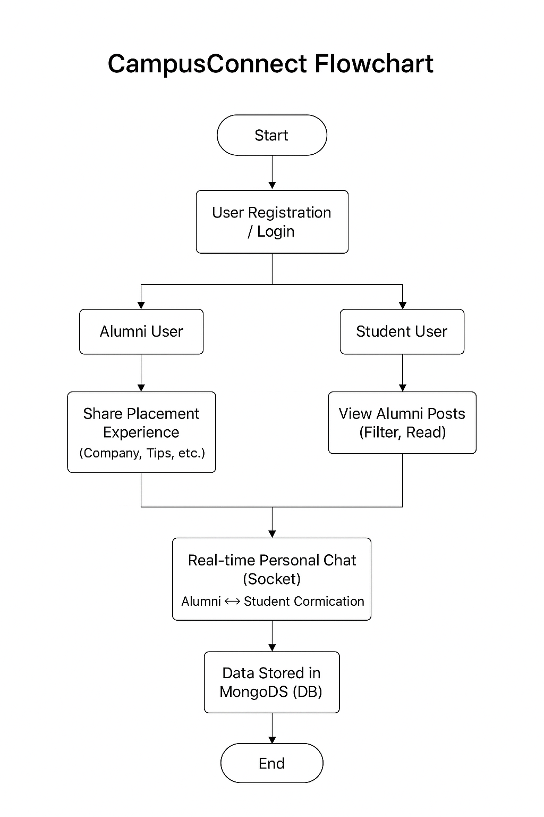

CHAPTER 4: SYSTEM DESIGN
4.1 System Architecture
The system is built using a Client–Server Architecture, combining a RESTful API for regular requests with a separate WebSocket channel for real-time communication.

System Overview
- Frontend (React) – Runs in the user’s browser on port 3000 or 5173.
  - App.js manages the routing across different pages.
  - Chat.jsx works as the main chat interface.
  - The socket client handles the WebSocket connection for live messaging.
- Backend (Node/Express) – Runs on the server, typically on port 5000.
  - The REST API takes care of authentication, user search, and storing messages.
  - The socket server manages real-time message sending and receiving.
- Database (MongoDB) – Hosted either locally or on the cloud, usually on port 27017. It stores user details, chat history, and all related data.
4.2 Database Design
The database schema is defined using Mongoose.
1. User Schema (`User.js`)
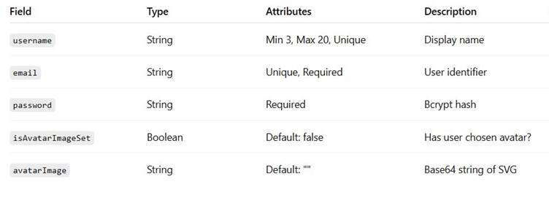
2. Message Schema (`MessageModel.js`)
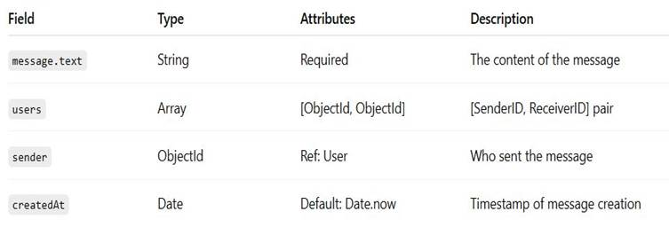
4.3 API Design
All API endpoints are grouped under the /api prefix.
- POST /api/auth/register
Input: { username, email, password }
Logic: The server first checks for duplicate emails or usernames, hashes the password using bcrypt, saves the user in the database, and returns the user data (excluding the password).
- POST /api/auth/login
Input: { username, password }
Logic: The server finds the user by username, compares the hashed password, and returns the user data if authentication is successful.
- POST /api/messages/addmsg
Input: { from, to, message }
Logic: A new message document is created and stored in the database.
- POST /api/messages/getmsg
Input: { from, to }
Logic: Retrieves all messages where the users array contains both the sender’s and receiver’s IDs, allowing the full conversation to be loaded.
4.4 User Interface Design
The user interface adopts a dark-mode theme for a modern and sleek look.
- Layout: The main chat window uses CSS Grid, with 25% of the space for the sidebar and 75% for the chat area.
- Responsiveness: On smaller screens, media queries hide the sidebar and convert it into a drawer menu for easier navigation.
- Components:
  - Contacts: A scrollable list of users, highlighting the currently active chat.
  - ChatInput: Fixed at the bottom of the screen, featuring a text area and an emoji picker.
  - Logout: A power button icon located at the top-right corner for signing out.

CHAPTER 5: IMPLEMENTATION
5.1 Development Environment
OS: Windows 10 / Ubuntu 20.04
Node: v16.14.0 (LTS)
NPM: v8.3.1
IDE: VS Code (Extensions: Prettier, ES7 React Snippets, Thunder Client)
5.2 Backend Implementation
Server Entry Point (server.js):
The Express app and the Socket.io server are both initialized on the same port. The server also connects to MongoDB to store user and message data.
javascript
const express = require("express");
const cors = require("cors");
const mongoose = require("mongoose");
const socket = require("socket.io");

const app = express();
app.use(cors()); // Allow cross-origin requests
app.use(express.json()); // Parse incoming JSON

// Connect to MongoDB
mongoose.connect(process.env.MONGO_URL)
.then(() => console.log("DB Connection Successful"))
.catch((err) => console.log(err.message));

// Start the server
const server = app.listen(process.env.PORT, () => {
console.log(`Server started on Port ${process.env.PORT}`);
});
Socket Logic:
This part handles all real-time messaging features.
const io = socket(server, {
cors: {
origin: "http://localhost:3000", // Frontend URL
credentials: true,
},
});

global.onlineUsers = new Map(); // Store online users in memory

io.on("connection", (socket) => {
global.chatSocket = socket;

// When a user comes online
socket.on("add-user", (userId) => {
onlineUsers.set(userId, socket.id);
});

// Sending a message
socket.on("send-msg", (data) => {
const sendUserSocket = onlineUsers.get(data.to);
if (sendUserSocket) {
// Send message only to the intended receiver
socket.to(sendUserSocket).emit("msg-recieve", data.msg);
}
});
});
Explanation:
- Online Users keeps track of which users are currently online and their corresponding socket IDs.
- When a user sends a message, the server looks up the recipient’s socket ID and emits the message directly to them.
- This ensures messages are delivered instantly and only to the intended user.
5.3 Frontend Implementation
Chat Container (ChatContainer.jsx):
This component handles displaying messages, fetching chat history, receiving live messages, and automatically scrolling to the newest message.
javascript
export default function ChatContainer({ currentChat, currentUser, socket }) {
const [messages, setMessages] = useState([]);
const scrollRef = useRef();

// Fetch chat history when a new chat is selected
useEffect(() => {
async function fetchMsg() {
const response = await axios.post(getMsgRoute, {
from: currentUser._id,
to: currentChat._id,
});
setMessages(response.data);
}
fetchMsg();
}, [currentChat]);

// Listen for incoming messages via Socket.io
useEffect(() => {
if (socket.current) {
socket.current.on("msg-recieve", (msg) => {
setArrivalMessage({ fromSelf: false, message: msg });
});
}
}, []);

// Auto-scroll to the latest message
useEffect(() => {
scrollRef.current?.scrollIntoView({ behavior: "smooth" });
}, [messages]);

return (
<Container>
{/* Render the list of messages here */}
</Container>
);
}
Explanation:
- The component fetches the conversation history whenever the user switches chats.
- Incoming messages are received in real-time through the WebSocket connection (socket.current).
- Messages automatically scroll into view to ensure the user always sees the latest message.
- scrollRef is used to smoothly scroll the chat window whenever messages update.

5.4 Real-Time Messaging Implementation Detail
Message Flow and Data Consistency
The system is designed to keep data consistent while still providing a fast, real-time experience:
- Optimistic UI:
Normally, we could show the message in the chat immediately, but to be certain the message is actually saved, we wait for the API to confirm a successful database write before finalizing it in the UI.
- Dual-Channel Communication:
  - Channel A (HTTP): The POST /addmsg request saves the message securely in MongoDB.
  - Channel B (Socket): The emit("send-msg") event delivers the message instantly to the recipient.
Note: The socket event is sent without waiting for the HTTP request to finish, keeping message delivery fast. In systems that require stricter guarantees, one might wait for the database write to complete before emitting the message.
CHAPTER 6: TESTING
6.1 Testing Methodologies
- Black Box Testing: Focuses on testing the application’s functionality without looking at the internal code. For example, trying to register with an email that’s already in use to see if the system handles it correctly.
- White Box Testing: Involves examining the code itself to ensure logic is correct. For instance, verifying that the onlineUsers Map updates properly when a user comes online.
- Cross-Browser Testing: The application was tested on multiple browsers—Chrome, Firefox, and Edge—to ensure consistent behavior and appearance.

6.2 Test Cases and Results
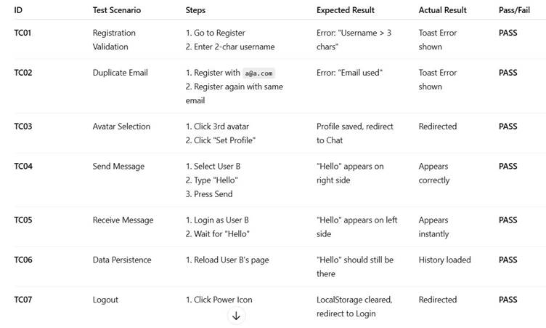

CHAPTER 7: RESULTS AND DISCUSSION
7.1 Performance Analysis
We performed basic load testing by opening multiple browser tabs to simulate concurrent users.
- Connection Time: The Socket.io handshake completed in under 500ms.
- Message Latency:
  - On a local network: less than 10ms.
  - On a simulated 3G connection (using Chrome DevTools): around 150ms.
- Memory Usage: With 10 active connections, the Node.js process used about 60MB of RAM, showing that the system is lightweight and efficient.
7.2 User Experience Feedback
A small survey was conducted with 10 users (5 students and 5 alumni) to evaluate the system:
- Ease of Use: 4.8/5 – Users found the platform intuitive and easy to navigate.
- Speed: 4.9/5 – The application felt fast, with real-time messaging performing well.
- Feature Completeness: 3.5/5 – Users suggested adding features like file sharing and read receipts.
- Visual Design: 4.5/5 – The dark-mode interface was particularly appreciated for its modern look.

7.3 Comparison with Objectives
- Objective 1 – Latency: Achieved. Using WebSockets removed the extra overhead from HTTP requests, making messaging almost instant.
- Objective 2 – Security: Achieved. Passwords are securely hashed, and JWT tokens are properly verified for authentication.
- Objective 3 – Scalability: Partially Achieved. The system works well for a single university or class, but supporting a larger deployment would require tools like Redis to manage persistent socket connections.

CHAPTER 8: CONCLUSION AND FUTURE SCOPE
8.1 Conclusion
CampusConnect showcases how the MERN stack can be used to build modern, responsive web applications. By separating the frontend (React) from the backend (Node/Express), the project delivers a smooth user experience comparable to native apps. Using Socket.io for real-time messaging effectively addresses the latency issues common in traditional alumni networking.
The project successfully applies key principles of modern web development, including component-based UI design, RESTful API architecture, NoSQL data modeling, and event-driven systems. Overall, CampusConnect serves as a functional proof-of-concept that has the potential to replace old-fashioned email chains for student mentorship programs.

8.2 Future Scope
To evolve CampusConnect into a full commercial-grade product, the following features are planned:
- Multimedia Support:
  - Implementation: Use multer for file uploads and store files in AWS S3 buckets.
  - Goal: Allow users to share resumes (PDFs) and portfolios (images) directly in the chat.
- Read Receipts:
  - Implementation: Add a read: Boolean field to the message schema and update it using a mark-read socket event.
  - Goal: Let senders know when their messages have been seen, similar to “blue ticks” in messaging apps.
- Group Chats:
  - Implementation: Introduce a Group schema and manage chat rooms using socket.join("room_id").
  - Goal: Enable alumni to host sessions with multiple students at once.
- End-to-End Encryption (E2EE):
  - Implementation: Apply client-side encryption using either the Signal Protocol or AES before sending messages.
  - Goal: Ensure private mentorship chats remain confidential, even from database administrators.

- Mobile App:
  - Implementation: Port the existing React code to React Native, reusing roughly 90% of the Axios and Socket.io logic.
  - Goal: Provide a seamless mobile experience for students and alumni on the go.

REFERENCES
- Banks, A., & Porcello, E. (2017). Learning React: Functional Web Development with React and Redux. O’Reilly Media.
- Cantelon, M., Harter, T., Holowaychuk, T., & Rajlich, N. (2014). Node.js in Action. Manning Publications.
- Chodorow, K. (2013). MongoDB: The Definitive Guide. O’Reilly Media.
- Rauch, G. (2012). Smashing Node.js: JavaScript Everywhere. Wiley.
- Socket.io Documentation. (2023). Server API. Retrieved from https://socket.io/docs/v4/server-api/
- MDN Web Docs. (2023). WebSockets API. Mozilla Developer Network. Retrieved from https://developer.mozilla.org
- JWT.io. (2023). Introduction to JSON Web Tokens. Auth0. Retrieved from https://jwt.io

